[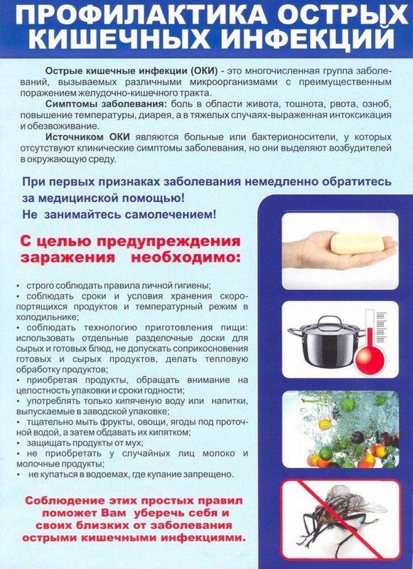](https://gkb11.medgis.ru/uploads/userfiles/organization_102/Publications/oki-0.jpg)